1. Download and install/extract **OpenSSL** (de pe sakai/ C tools)
2. Open **Visual Studio**
3. File>New>Project>**Win 32 Console Application** ….Name… OK

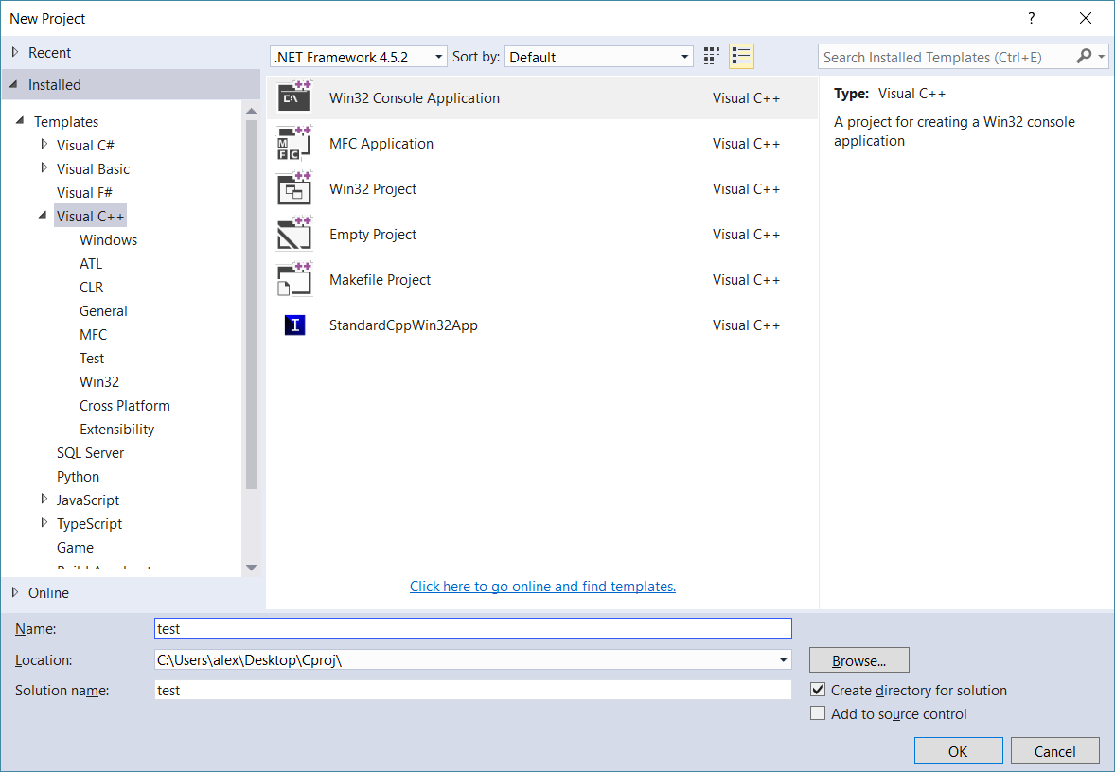

1. Next ->Console Application >bifa doar la Empty project -> Finish

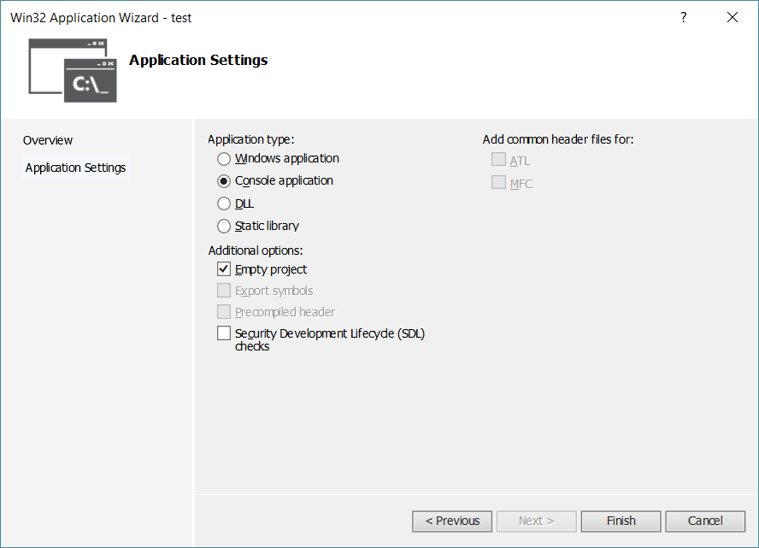

1. click dreapta pe Source Files in Solution Explorer, Add -> New Item -> cpp file
2. write or copy/paste din fisierele cu hash-uri puse pe drive in SAP-restanta/exemple practice (C_MD5.txt, C_SHA .txt, C_SHA256.txt)
3. pt. fisier.txt click dreapta pe proiect, Open Folder in File Explorer apoi copy paste fisier:

// pt uncomment select all > Ctrl+K apoi Ctrl+U

// pt coment select all > Ctrl+K apoi Ctrl+C

9. click dreapta pe proiect, Properties:

* Debugging -> Command Arguments -> calea catre fisierul de hash-uit (daca ai facut pasul 7 treci doar numele fisier.txt ?)
* C/C++ -> **Additional include directories** -> calea catre folderul **‘include’** din openssl
* Linker -> Command line-> C:\OpenSSL\lib\VC\libeay32MTd.lib C:\OpenSSL\lib\VC\libeay32MDd.lib

Make sure the following settings are setup in the project property pages:

[C/C++ -> General -> Additional Include Directories] value: OpenSSL’s include directory in your machine (e.g C:\openssl\include) or (e.g C:\openssl\include64)

[Linker -> General -> Additional Library Directories] value: OpenSSL’s lib directory in your machine (e.g C:\openssl\lib) or (e.g C:\openssl\lib64)

[Linker -> Input -> Additional Dependencies] value: ws2_32.lib libsslMT.lib Crypt32.lib libcryptoMT.lib

ctrl+f5 -RUN

OpenSSL

MD5:

cl.exe /Ic:\OpenSSL\include /P /c ex30_MD5.cpp

cl.exe /Ic:\OpenSSL\include /FoAppMD5 c:\OpenSSL\lib\VC\libeay32MTd.lib ex30_MD5.cpp

For Visual Studio compiling use next settings:

Debug -> arguments: the path of the file you want to get MD5 for

C/C++ -> Additional include directories -> c:/openssl/include

Linker -> Command line-> C:\openssl\lib\VC\libeay32MTd.lib

SHA256:

inlocuiesti si tu p’acolo prin MD5 cu SHA

AES:

key: hardcoded

Debug -> arguments: -e -cbc fSrc.txt fDst.txt

-d -ecb fSrc.txt fDst.txt");

C/C++ -> Additional include directories -> c:/openssl/include

Linker -> Command line-> C:\openssl\lib\VC\libeay32MTd.lib

RSA

Linker -> Command line-> C:\OpenSSL\lib\VC\static\libeay32MTd.lib C:\OpenSSL\lib\VC\static\libeay32MDd.lib

QT

qmake -project (in folderul cu .cpp)

qmake -config release

nmake